Borough of Ambridge
MINUTES
Council Meeting: September 8, 2020
Live Meeting – Fire Department Bay

- The September 8, 2020 meeting of Ambridge Borough Council was called to order at 6:30PM, in the Ambridge Fire Department Fire Truck Bays.

Mr. Mikulich announced that the Council has been searching for a new Borough Manager and today is the new Borough Manager’s first day. He introduced Mario Leone, Jr. Mr. Leone commented that he is looking forward to working Ambridge. He states that Ambridge has a great deal of potential and that was a deciding factor for him to take the position here in Ambridge. He is very eager to begin.

The Council met for an executive session prior to this meeting to discuss personnel and legal matters.

- Roll Call:
Present: Mr. Cafarelli
Mr. Dunn
Mr. Flannery
Mr. Gill
Mrs. Miller
Mr. Mikulich
Mrs. Tessaro
Mayor Drewnowski

Also Present: Borough Manager Mario Leone Jr., Chief Gottschalk Police Chief DeLuca and Solicitor Start remotely via phone call.

Absent: None.

- Invocation – the invocation was conducted by Mrs. Barbara Costa, Trinity School for Ministry,

- Pledge of Allegiance

- Presentations -
Mr. Mark Turnley, CPA presented a review of the 2019 Borough Audit to the Council.

- Citizen’s Participation On/Off Agenda Items (5 minutes per speaker)

- Stanley Williamson – He spoke about Duke McCoy fell and could not be here to speak. He spoke of the church across from Tick Tock and they give out food to senior and kids. If anyone wants to pick up a meal and take it to someone who needs it, you are welcome to do so.

- Approval of Previous Meeting Minutes -August 11, 2020.
Mr. Flannery made the motion to accept the minutes, seconded by Mrs. Miller; a roll call vote was taken:

Council | Vote |  | Council | Vote
Mr. Cafarelli | Yes |  | Mrs. Miller | Yes
Mr. Dunn | Yes |  | Mrs. Tessaro | Yes
Mr. Flannery | Yes |  | Mr. Mikulich | Yes
Mr. Gill | Yes |  | Mayor Drewnowski
Motion carried.

- Borough Bills and Expenses

1. General Fund Unpaid: $70,095.05 Paid: $48,818.22
2. Grants / Special Project Fund Unpaid: $0.00
3. Recreation Fund Unpaid: $0.00 Paid: $0.00
4. Escrow Fund Unpaid: $0.00
5. Police Pension Fund Unpaid: $0.00
6. Service Employees Pension Fund Unpaid: $0.00
7. Firemen’s Pension Fund Unpaid: $0.00
8. Drug Investigation Fund Unpaid: $0.00
9. Fire Apparatus Replacement Fund Unpaid: $0.00

Motion to pay the bills was made by Mrs. Miller, seconded by Mr. Flannery; a roll call vote was taken:

Council | Vote |  | Council | Vote
Mr. Cafarelli | Yes |  | Mrs. Miller | Yes
Mr. Dunn | Yes |  | Mrs. Tessaro | Yes
Mr. Flannery | Yes |  | Mr. Mikulich | Yes
Mr. Gill | Yes |  | Mayor Drewnowski
Motion carried.

- Consent Agenda:
Those matters included under the consent agenda are self-explanatory and are not expected to require further review or discussion. Items will be enacted by one motion. If discussion is desired by any member of Council, that item must be removed from the consent agenda and considered separately.

Motion to accept item 3 listed on the Consent Agenda; all were in favor.

  - Borough Financial Report - acknowledge receipt of the Borough Treasurer’s Report.
  - Authorize the placement of a dedicated on-street handicap parking space at 1211 Beaver Rd as recommended by the Ambridge Police Department.
  - Authorize the placement of a dedicated on-street handicap parking space at 808 -22nd St. as recommended by the Ambridge Police Department.
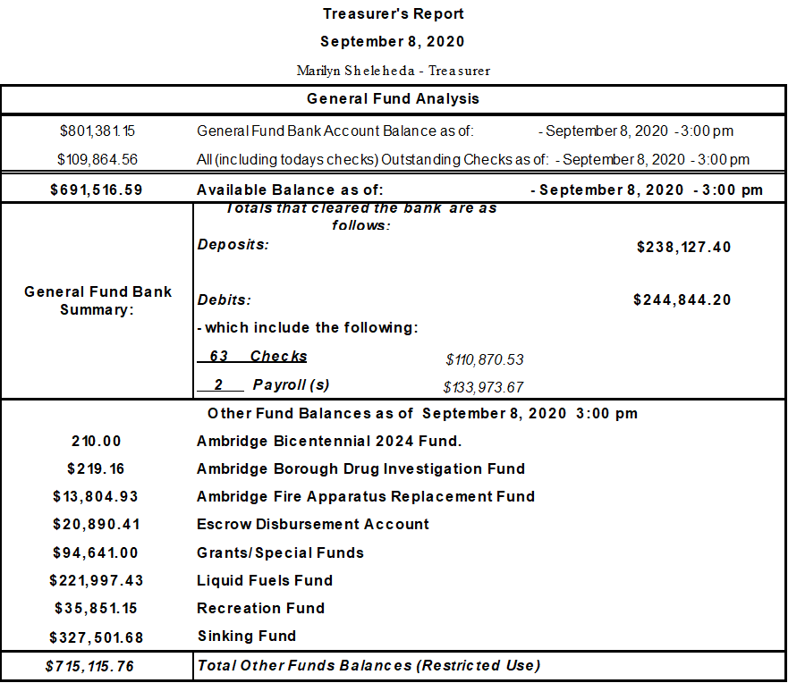

Motion carried unanimously to accept Consent Agenda item.

New Business - Items for Discussion:

A. Motion to Accept 2019 Audit Report as presented by Mark Turnley, CPA made by Mrs. Miller, seconded by Mr. Cafarelli. a roll call vote was taken:

Council | Vote |  | Council | Vote
Mr. Cafarelli | Yes |  | Mrs. Miller | Yes
Mr. Dunn | Yes |  | Mrs. Tessaro | Abstain
Mr. Flannery | Yes |  | Mr. Mikulich | Yes
Mr. Gill | Abstain |  | Mayor Drewnowski
Motion carried.

- Motion to adopt Minimum Municipal Obligation to the Borough’s Pension Plans: Police - $222,876.00, Fire -$33,065.00, Service Employees Defined Benefit -$82,603.00, Service Employees Defined Contribution - $11,999.00 made by Mr. Gill, seconded by Mr. Cafarelli. A roll call vote was taken:

Council | Vote |  | Council | Vote
Mr. Cafarelli | Yes |  | Mrs. Miller | Yes
Mr. Dunn | Yes |  | Mrs. Tessaro | Yes
Mr. Flannery | Yes |  | Mr. Mikulich | Yes
Mr. Gill | Yes |  | Mayor Drewnowski
Motion Carried.

- Motion to schedule 2021 Budget Meetings made by Mr. Cafarelli, seconded by Mrs. Tessaro.
Discusstion about the schedule that in the past was 2 hours prior to regular Council Meetings.
October 13, November 10, and if we need a 3rd meeting they will schedule it, if no third meeting, they will adopt it at the December meeting.
All in Favor – Motion carried.

- Motion to authorize the Tax Exoneration of property taxes for the parcel 10-004-0201.000 located across Beaver Road from New Hope Church to be used for Church activities made by Mrs. Tessaro, seconded by Mr. Flannery.
A roll call vote was taken:

Council | Vote |  | Council | Vote
Mr. Cafarelli | Yes |  | Mrs. Miller | Yes
Mr. Dunn | Yes |  | Mrs. Tessaro | Yes
Mr. Flannery | Yes |  | Mr. Mikulich | Yes
Mr. Gill | Yes |  | Mayor Drewnowski
Motion Carried.

- Motion to Exoneration of property taxes on Parcel #12-001-1103.000-1- located at 284 -13th Street requested by the Ambridge Historical District Economic Development Corp. -made by Mr. Flannery, seconded by Mrs. Miller.
A roll call vote was taken:

Council | Vote |  | Council | Vote
Mr. Cafarelli | Yes |  | Mrs. Miller | Yes
Mr. Dunn | Yes |  | Mrs. Tessaro | Yes
Mr. Flannery | Yes |  | Mr. Mikulich | Yes
Mr. Gill | Yes |  | Mayor Drewnowski
Motion Carried.

- Motion to Exoneration of property taxes on Parcel on Parcel #09-002-0225.000, located at 325 Maplewood Ave. made by Mrs. Miller, seconded by Mrs. Tessaro. A roll call vote was taken:

Council | Vote |  | Council | Vote
Mr. Cafarelli | Yes |  | Mrs. Miller | Yes
Mr. Dunn | Yes |  | Mrs. Tessaro | Yes
Mr. Flannery | Yes |  | Mr. Mikulich | Yes
Mr. Gill | Yes |  | Mayor Drewnowski
Motion Carried.

- Motion to Exoneration of property taxes on Parcel #10-002-0910.000, located at 540 Merchant Street made by Mr. Flannery, seconded by Mrs. Tessaro. A roll call vote was taken:

Council | Vote |  | Council | Vote
Mr. Cafarelli | Yes |  | Mrs. Miller | Yes
Mr. Dunn | Yes |  | Mrs. Tessaro | Yes
Mr. Flannery | Yes |  | Mr. Mikulich | Yes
Mr. Gill | Yes |  | Mayor Drewnowski
Motion Carried.

- Committee Reports.

Public Safety – Mr. Flannery

Mr Flannery met with Chief De Luca, the new vehicles are ordered and should be in after Labor Day. most of the officers have been trained with the Narcan Videos and will be in use. Video policy for newer officers with training being completed lights automatically and engaged or manual download will begin of each until server issue is resolved. Discuss straight the issues with follow up next month. Fire Department public safety - truck 71-1 is back in service rotate it's been Rd tested an will receive final bill after onspot chains installed . October multiple Department is doing a hose and ground ladder inspection. Have covid updates all department's need more PPE. In SCBA grant to be announced were hopeful paid researching grants and communications with Boro reps. Citizens fire Academy no interest shown on and will be on hold at the present time. Fire Department inquired about the Narcan for the firing code to be used and they will have discussions. Also staffing dual departments fire code hello requesting a eligibility list for a full time firefighter by civil service for the new year.

Motion made by Mr. Flannery to add the Fire Dept to the Civil Service eligibilty list testing, seconded by Mrs. Miller. A roll call vote was taken:

Council | Vote |  | Council | Vote
Mr. Cafarelli | Yes |  | Mrs. Miller | Yes
Mr. Dunn | Yes |  | Mrs. Tessaro | Yes
Mr. Flannery | Yes |  | Mr. Mikulich | Yes
Mr. Gill | Yes |  | Mayor Drewnowski
Motion Carried.

Mr. Drewnowski spoke about the Policy for the Police Dept. -#21 Narcan & #22 Recording devices. Mr. Mikulich asked Solicitor Start if he viewed the policies and Mr. Start said he reviewed them and approved them.
Mr. Gill made the motion to adopt the Resolutions and seconded by Mr. Cafarelli. A roll call vote was taken:

Council | Vote |  | Council | Vote
Mr. Cafarelli | Yes |  | Mrs. Miller | Yes
Mr. Dunn | Yes |  | Mrs. Tessaro | Yes
Mr. Flannery | Yes |  | Mr. Mikulich | Yes
Mr. Gill | Yes |  | Mayor Drewnowski
Motion Carried.

Mayor’s Report – Dave Drewnowski
Mr. Drewnowski commented that the Police Dept issued 24 traffic & 26 non traffic citations for August.

Code Committee – Tina Tessaro
Mrs. Tessaro reminded everyone that the tire recycling will be on October 10th at the Borough Building and you can find more information on Borough website and Borough Facebook page.

Public Works Committee – Tony Cafarelli
Ongoing - Borough Park Maintenance. trash pick-up, damage assessment.
Ongoing – Sign Maintenance around town.
Public Works Lot Repaving & Gravel Parking Spaces
10th Street Repaving by the Muscles Gym Building
Borough Properties Maintenance – grass cutting.
Storm Drain Cleaning
Storm Debris Clean Up – 4 large tree areas.
Multiple Right of Way – Trimmed & Cleaned Up
Potholes & alley repairs
Street Sweeping – storm clean up
Troop Banner Hanging & Maintenance.

Parks and Recreation Committee – Tina Miller
She has not had a meeting. She stated that the Ambridge Youth Association wanted to place a plaque in Panek Park at the ball field to recognize Mr. Mike Galvan for all the years he has donated his time to the Youth Association. Mrs. Miller made to motion to dedicate the Ball Field closet to the concession stand to Mr. Galvan – seconded by Mr. Cafarelli. A roll call vote was taken:

Council | Vote |  | Council | Vote
Mr. Cafarelli | Yes |  | Mrs. Miller | Yes
Mr. Dunn | Yes |  | Mrs. Tessaro | Yes
Mr. Flannery | Yes |  | Mr. Mikulich | Yes
Mr. Gill | Yes |  | Mayor Drewnowski
Motion Carried.

Some discussion on how to handle Trick or Treat at the Borough. (Some discussion inaudible)
Mrs. Tessaro states that if there is a date set. - we can use that date; how can you stop people for handing out candy.

Engineer’s Report – Chris Suehr
He spoke on the Merchant Street and Municipal Lots resurfacing. He informed Hancock architects of the pavement sinkage near 8th St. and settling of bricks in a crosswalk. Requested they investigate and respond back to the Borough within 2 weeks. He spoke of the 2020 misc. road work thought the Borough, the completed paving in Public Works yard and the resurfacing of 10th St (from the Park ‘n Ride to Glenwood). He stated that the annual MS4 Report is due on September 30th, also requested info from Public Works on sediment filter bags placed in the French Point Creek area. Pending issues are with Columbia Gas about emergency repaired patches on Kennedy Dr and Church St. that are still waiting for resurfacing. Church St. will be done ASAP, but Kennedy will wait until next year, because they don’t want to have to resurface twice – they will work there again next year.

Mr. Mikulich has asked Mr. Suehr to check on the demolished building near the ice cream shop on 4th and Merchant to make sure the sidewalk has not been damaged, if he has – the contractor is responsible for replacing the sidewalk. The did put plywood down and sand over the sidewalk but we just want to check. Mr. Suehr stated he will check on it.

Motion to accept all official reports made by Mrs. Miller, seconded by Mrs. Tessaro. A roll call vote was taken:

Council | Vote |  | Council | Vote
Mr. Cafarelli | Yes |  | Mrs. Miller | Yes
Mr. Dunn | Yes |  | Mrs. Tessaro | Yes
Mr. Flannery | Yes |  | Mr. Mikulich | Yes
Mr. Gill | Yes |  | Mayor Drewnowski
Motion Carried.

- Other Unfinished Business: None
Mayor wanted to thank Council (inaudible)
Mr. Leone commented about the Covid Grant that the office staff & both chiefs helped him with the data so that he could complete it. We submitted a grant for a possible $720,384.21 of which this is primarily police and fire wages & benefits and some of the other costs to the Borough during the Covid crisis. We were told that we cannot expect the entire amount, but they are going to construct some formula based on population vs the amount requested.
And his understanding is that Ambridge Borough had a higher amount, maybe Beaver Falls and maybe Hopewell was higher. We can probably expect $200,000.00 – which will help offset our wage tax short falls that Mr. Turnley spoke of.

- Adjournment –
Motion to adjourn was made by Mr. Cafarelli, seconded by Mrs. Tessaro; motion carried unanimously – meeting was adjourned.

Respectfully submitted:

_________________________
Mario Leone, Jr.
Borough Manager / Secretary

