Borough of Ambridge
MINUTES
Council Meeting: October 13, 2020
Live Meeting – Fire Department Bay

- The October 13, 2020 meeting of Ambridge Borough Council was called to order at 6:30PM, in the Ambridge Fire Department Fire Truck Bays.

- Roll Call:
Present: Mr. Dunn
Mr. Flannery
Mr. Gill
Mrs. Miller
Mr. Mikulich
Mrs. Tessaro
Mayor Drewnowski

Also Present: Borough Manager Mario Leone Jr., Chief Gottschalk Police Chief DeLuca and Solicitor Start remotely via phone call.

Absent: Mr. Cafarelli.

- The Council met for an executive session prior to this meeting to discuss personnel and legal matters.

- Invocation – the invocation was conducted by Mrs. Barbara Costa, Trinity School for Ministry,

- Pledge of Allegiance

Mr. Mikulich recognized Mr. Gill to have the floor.
Mr. Gill introduced Stu Otto from the Center for Hope. He stated that Greater Pittsburgh Food bank wanted to install 40 Refrigerated Food Lockers – 28 ft long. Mr. Mikulich didn’t see an issue with the legal aspect, the Fire Dept. didn’t have any concerns. Mr. Otto stated probably the end of November the lockers will be installed.

- Presentations - None.

- Citizen’s Participation On/Off Agenda Items (5 minutes per speaker)

Chad Wiliamson – 1st Baptist Church @ 300 -11th St. – Free hot meal from 12 – 2 every Friday. They gave out last Friday 170 free dinners.

- Approval of Previous Meeting Minutes
September 8, 2020.
Motion Made by Mrs. Miller, seconded by Mr. Gill. No questions or corrections.

Council | Vote |  | Council | Vote
Mr. Cafarelli | Absent |  | Mrs. Miller | YES
Mr. Dunn | YES |  | Mrs. Tessaro | YES
Mr. Flannery | YES |  | Mr. Mikulich | YES
Mr. Gill | YES |  | Mayor Drewnowski
Motion Carried.

- Borough Bills and Expenses
General Fund Unpaid: $698,133.46 Paid: 119,849.52
Grants/Special Fund Unpaid: $ 2,451.56
Recreation Fund Unpaid: $ .00
Escrow Fund Unpaid: $ .00
Police Pension Fund Unpaid: $ .00
Service Employee Pension Fund Unpaid: $ .00
Firemen’s Pension Fund Unpaid: $ .00
Drug Investigation Fund Unpaid: $ .00
Fire Apparatus Fund Unpaid: $ .00

Motion made by Mr. Flannery to approve the bills and expenses, seconded by Mrs. Miller. No questions or corrections.

Council | Vote |  | Council | Vote
Mr. Cafarelli | Absent |  | Mrs. Miller | YES
Mr. Dunn | YES |  | Mrs. Tessaro | YES
Mr. Flannery | YES |  | Mr. Mikulich | YES
Mr. Gill | YES |  | Mayor Drewnowski
Motion Carried.

- Consent Agenda:
Those matters included under the consent agenda are self-explanatory and are not expected to require further review or discussion. Items will be enacted by one motion. If discussion is desired by any member of Council, that item must be removed from the consent agenda and considered separately.

  - Borough Financial Report – acknowledge receipt of the Borough Treasurer’s Report.

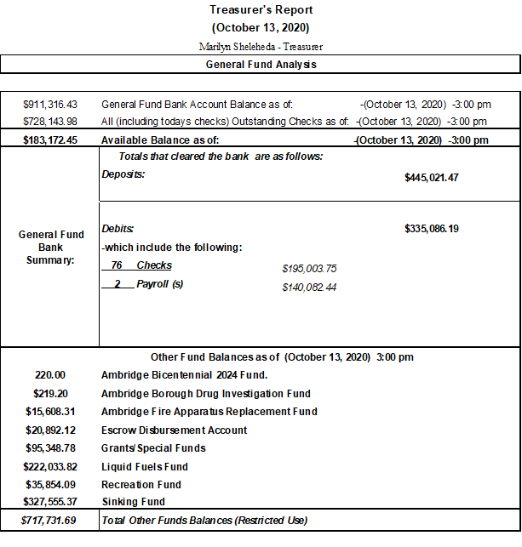

  - Placement of a dedicated on-street handicap parking space at 900 Glenwood Ave.
  - Approve Halloween – Trick or Treat night for Thursday October 29th from 6:00p – 8:00p

Motion to accept items 1 through 3 on Consent Agenda; Motion carried unanimously.

NEW BUSINESS

- Motion to reject the Solid Waste and Recycling Collection Bids received by the Borough on September 15th and re-advertise for the solicitation bids for a 5-year contract 2021-2025.
Motion made by Mr. Flannery – seconded by Mr. Dunn.

Council | Vote |  | Council | Vote
Mr. Cafarelli | Absent |  | Mrs. Miller | YES
Mr. Dunn | YES |  | Mrs. Tessaro | YES
Mr. Flannery | YES |  | Mr. Mikulich | YES
Mr. Gill | YES |  | Mayor Drewnowski
Motion Carried.

- Motion to approve Resolution 2020-11 appointing Borough Manager Mario Leone Jr as Pension Administrator. Motion made by Mr. Miller, seconded by Mr. Gill. No questions on the motion.

Council | Vote |  | Council | Vote
Mr. Cafarelli | Absent |  | Mrs. Miller | YES
Mr. Dunn | YES |  | Mrs. Tessaro | YES
Mr. Flannery | YES |  | Mr. Mikulich | YES
Mr. Gill | YES |  | Mayor Drewnowski
Motion Carried.

- Motion to make payment to the Volunteer Fire Relief Association in the amount of $21,958.69.
Motion made by Mr. Flannery, seconded by Mr. Dunn.

Council | Vote |  | Council | Vote
Mr. Cafarelli | Absent |  | Mrs. Miller | YES
Mr. Dunn | YES |  | Mrs. Tessaro | YES
Mr. Flannery | YES |  | Mr. Mikulich | YES
Mr. Gill | YES |  | Mayor Drewnowski
Motion Carried.

- Motion to authorize application for a Rivers of Steel Heritage Area Mini-Grant for Signage and Marketing of newly designated Historic District. Borough match will be in-kind labor.
Mr. Mikulich explained that these are for the newly zoning that we got approved for, these markers would be like those that are already down in the Old Economy Historical District. Mrs. Tessaro asked for an explanation on what the “in-kind labor” would be, Mr. Mikulich responded that the Borough would be providing the labor to install the signage. Motion to authorize Mrs. Miller and seconded by Mr. Gill.

Council | Vote |  | Council | Vote
Mr. Cafarelli | Absent |  | Mrs. Miller | YES
Mr. Dunn | YES |  | Mrs. Tessaro | YES
Mr. Flannery | YES |  | Mr. Mikulich | YES
Mr. Gill | YES |  | Mayor Drewnowski
Motion Carried.

- Motion to Authorize PA. Commission on Crime and Delinquency for the Police Body Worn Cameras in the amount of $46,417.25 with a 50% match requirement.
Motion made by Mrs. Miller, seconded by Mr. Gill. No questions on the motion.

Council | Vote |  | Council | Vote
Mr. Cafarelli | Absent |  | Mrs. Miller | YES
Mr. Dunn | YES |  | Mrs. Tessaro | YES
Mr. Flannery | YES |  | Mr. Mikulich | YES
Mr. Gill | YES |  | Mayor Drewnowski
Motion Carried.

Committee Reports.

Public Safety: Mr. Flannery gave his report on Police Procedures. Motion made by Mr. Flannery, seconded by Mrs. Miller. Mrs. Tessaro asked if Council can get a copy of the policies.

Council | Vote |  | Council | Vote
Mr. Cafarelli | Absent |  | Mrs. Miller | YES
Mr. Dunn | YES |  | Mrs. Tessaro | YES
Mr. Flannery | YES |  | Mr. Mikulich | YES
Mr. Gill | YES |  | Mayor Drewnowski
Motion Carried.

PUBLIC SAFETY - Mr. Mikulich wanted to recognize the Ambridge Vol. Fire Department and the paid Fire Department. While the Covid has been made the fundraising for the Fire Dept. almost zero, our Fire Dept has not been sitting idle. Capt. Gorecki applied for and received a grant from the State which off-sets some of the expenses that the F.D. incurred during COVID. The grant is $23,288.00 for the paid fire dept. and the volunteers will receive $24,110.00. These are very substantial grants. Thank you Chief, Assistant Chief and Capt. Gorecki.

MAYOR’S REPORT: Mayor Drewnowski spoke on the large drug bust that Ambridge had the previous week. He asked the Police Chief DeLuca to elaborate. Chief DeLuca commented that the bust involving heroin. Mayor also wanted to recognize the two officers for administering Narcan and saving a life. Chief DeLuca read the commendation letter to Officer Causer and Officer Turner. Mr. Mikulich commented that this was outstanding.

CODE COMMITTEE: Mrs. Tessaro gave her report had a meeting October 1st and it was very informative.

PUBLIC WORKS: No report.

PARKS & RECREATION: Mrs. Miller asked for permission for the Chamber of Commerce to have the Christmas Parade. Mr. Mikulich asked if there were any issues or concerns – no comments. Mr. Mikulich asked if there were any plans to have anything in the PJ Caul Park, and Mrs. Miller said there were no immediate plans they would discuss it as it gets closer. Mrs. Miller also comme4nted that Trick or Treat will be on the 29th from 6:00pm until 8:00pm.

ENGINEER’S REPORT:

1. Merchant Street (and Municipal Lots) Resurfacing:
- Forwarded response from Hancock Architects regarding spot sinkage in pavement on Merchant near 8th Street.
2. 2020 Road Program:
• Received, reviewed and recommended payment of Progress Payment No. 1 for the paving of Public Works Yard and 10th Street.
• Withheld 3% retainage until we receive a response regarding additional sealing requested in Public Works Yard.
3. Annual MS4 Reporting:
• Attended DEP field audit
• Submitted annual report to DEP

MANAGERS REPORT: Mr. Leone wanted to update Council on a few items. He said the two grants that they have been working on are due this week. He is working with Ann Sutherland who is a business owner of local antique store, who has volunteered to help and seems to be knowledgeable in this process. Recently there has been an announcement for the DCNR grant for $315,000.00 and that project is about $630,000.00 for the Henning St Park. There is another component of it that is a Land and Water Conservation Fund that previous manager was working on and we are encouraged to submit another grant for our 50% match which would be $315,000.00, that deadline is mid-November. We can then move forward with the new park. We need to have a budget meeting. Some discussion to set the budget meetings for October 20 – 4:00pm. November 17th - 4:00pm - No objection from Council.

Motion to accept all official reports made by Mr. Flannery, seconded by Mr. Dunn. No questions on any reports. Motion carried unanimously

UNFINISHED BUSINESS:
Mrs. Tessaro commented about Library is partnering with the YMCA to have a mobile YMCA 4:00 – 5:00. Also, Trunk or Treat on October 28th.

Mr. Mikulich commented that back on Oct 13th, 1775 by an act of Resolution – the Continental Congress established the United States Navy. Today it’s 245th birthday.

Motion to Adjourn @7:10pm:
Motion made by Mr. Gill, seconded by Mrs. Miller.
Motion carried unanimously

